**To Create a database in sql**

-- Step 1: Create the database (run this in pgAdmin or psql if needed)

CREATE DATABASE sales_data;

-- Step 2: Connect to the new database, then create the table

CREATE TABLE sales (

row_id INT PRIMARY KEY,

order_id TEXT,

order_date DATE,

ship_date DATE,

ship_mode TEXT,

customer_id TEXT,

customer_name TEXT,

segment TEXT,

country TEXT,

city TEXT,

state TEXT,

postal_code INT,

region TEXT,

product_id TEXT,

category TEXT,

sub_category TEXT,

product_name TEXT,

cost FLOAT,

price FLOAT,

profit FLOAT,

quantity INT,

sales FLOAT

);

**To Insert File In Database**

COPY sales

FROM '/path/to/cleaned_sales_data.csv'

DELIMITER ','

CSV HEADER;

**Create Views**

View: Average Sales, Profit, Cost

CREATE VIEW AvgSalesProfitCost as

SELECT avg(sales) as avg_sales, avg(profit) as avg_profit, avg(cost) as avg_cost FROM sales;

SELECT * FROM AvgSalesProfitCost;

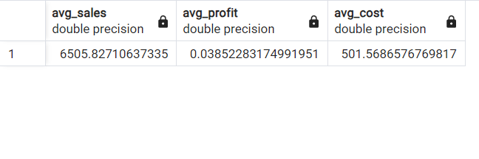

View: Total Sales, Profit, Cost

CREATE VIEW TotalSalesProfitCost as

SELECT sum(sales) as total_sales, sum(profit) as total_profit, sum(cost) as total_cost FROM sales;

SELECT * FROM TotalSalesProfitCost;

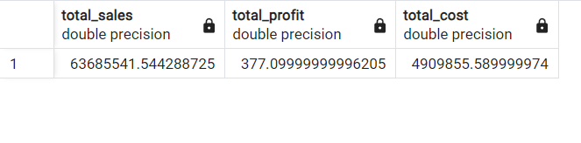

View: Count of entries by Region

CREATE VIEW RegionCount as

SELECT region, count(*) as count FROM sales GROUP by region ORDER by count desc;

Select * FROM RegionCount;

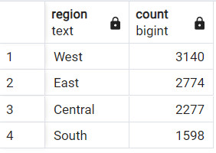

**Data Analysis Queries**

Products with “Standard Class”, Profit > 850, and Quantity < 5

SELECT product_name FROM sales

WHERE ship_mode = 'standard class' AND profit > 850 AND quantity < 5

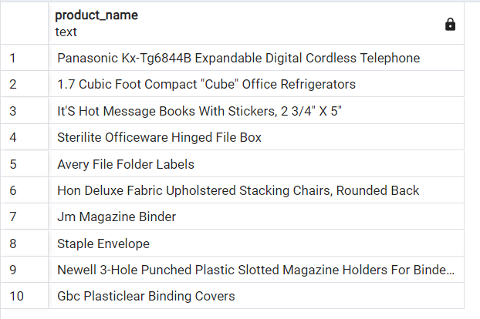

**Top 10 Products below Average Sales**

SELECT product_id, product_name FROM sales

where sales < (SELECT avg(sales) from sales) ORDER by sales DESC LIMIT 10;

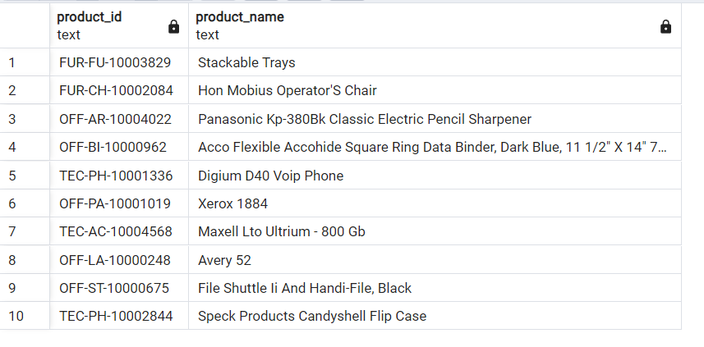

**Products with the Same Quantity (Standard Class), May Include Self-Match**

SELECT DISTINCT s1.product_id, s1.product_name, s1.quantity

FROM sales s1 JOIN sales s2 on s1.quantity = s2.quantity AND s1.ship_mode = 'standard class' ORDER by s1.quantity DESC LIMIT 10;

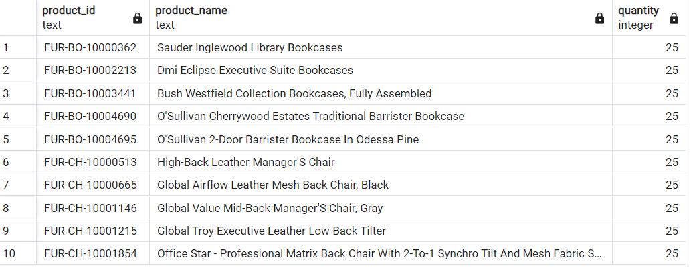

**Products with Same Quantity (Standard Class), Excluding Self-Match**

SELECT DISTINCT s1.product_id, s1.product_name, s1.quantity

FROM sales s1 JOIN sales s2 on s1.quantity = s2.quantity AND s1.ship_mode = 'standard class' AND s1.product_id <> s2.product_id ORDER by s1.quantity DESC LIMIT 10;

